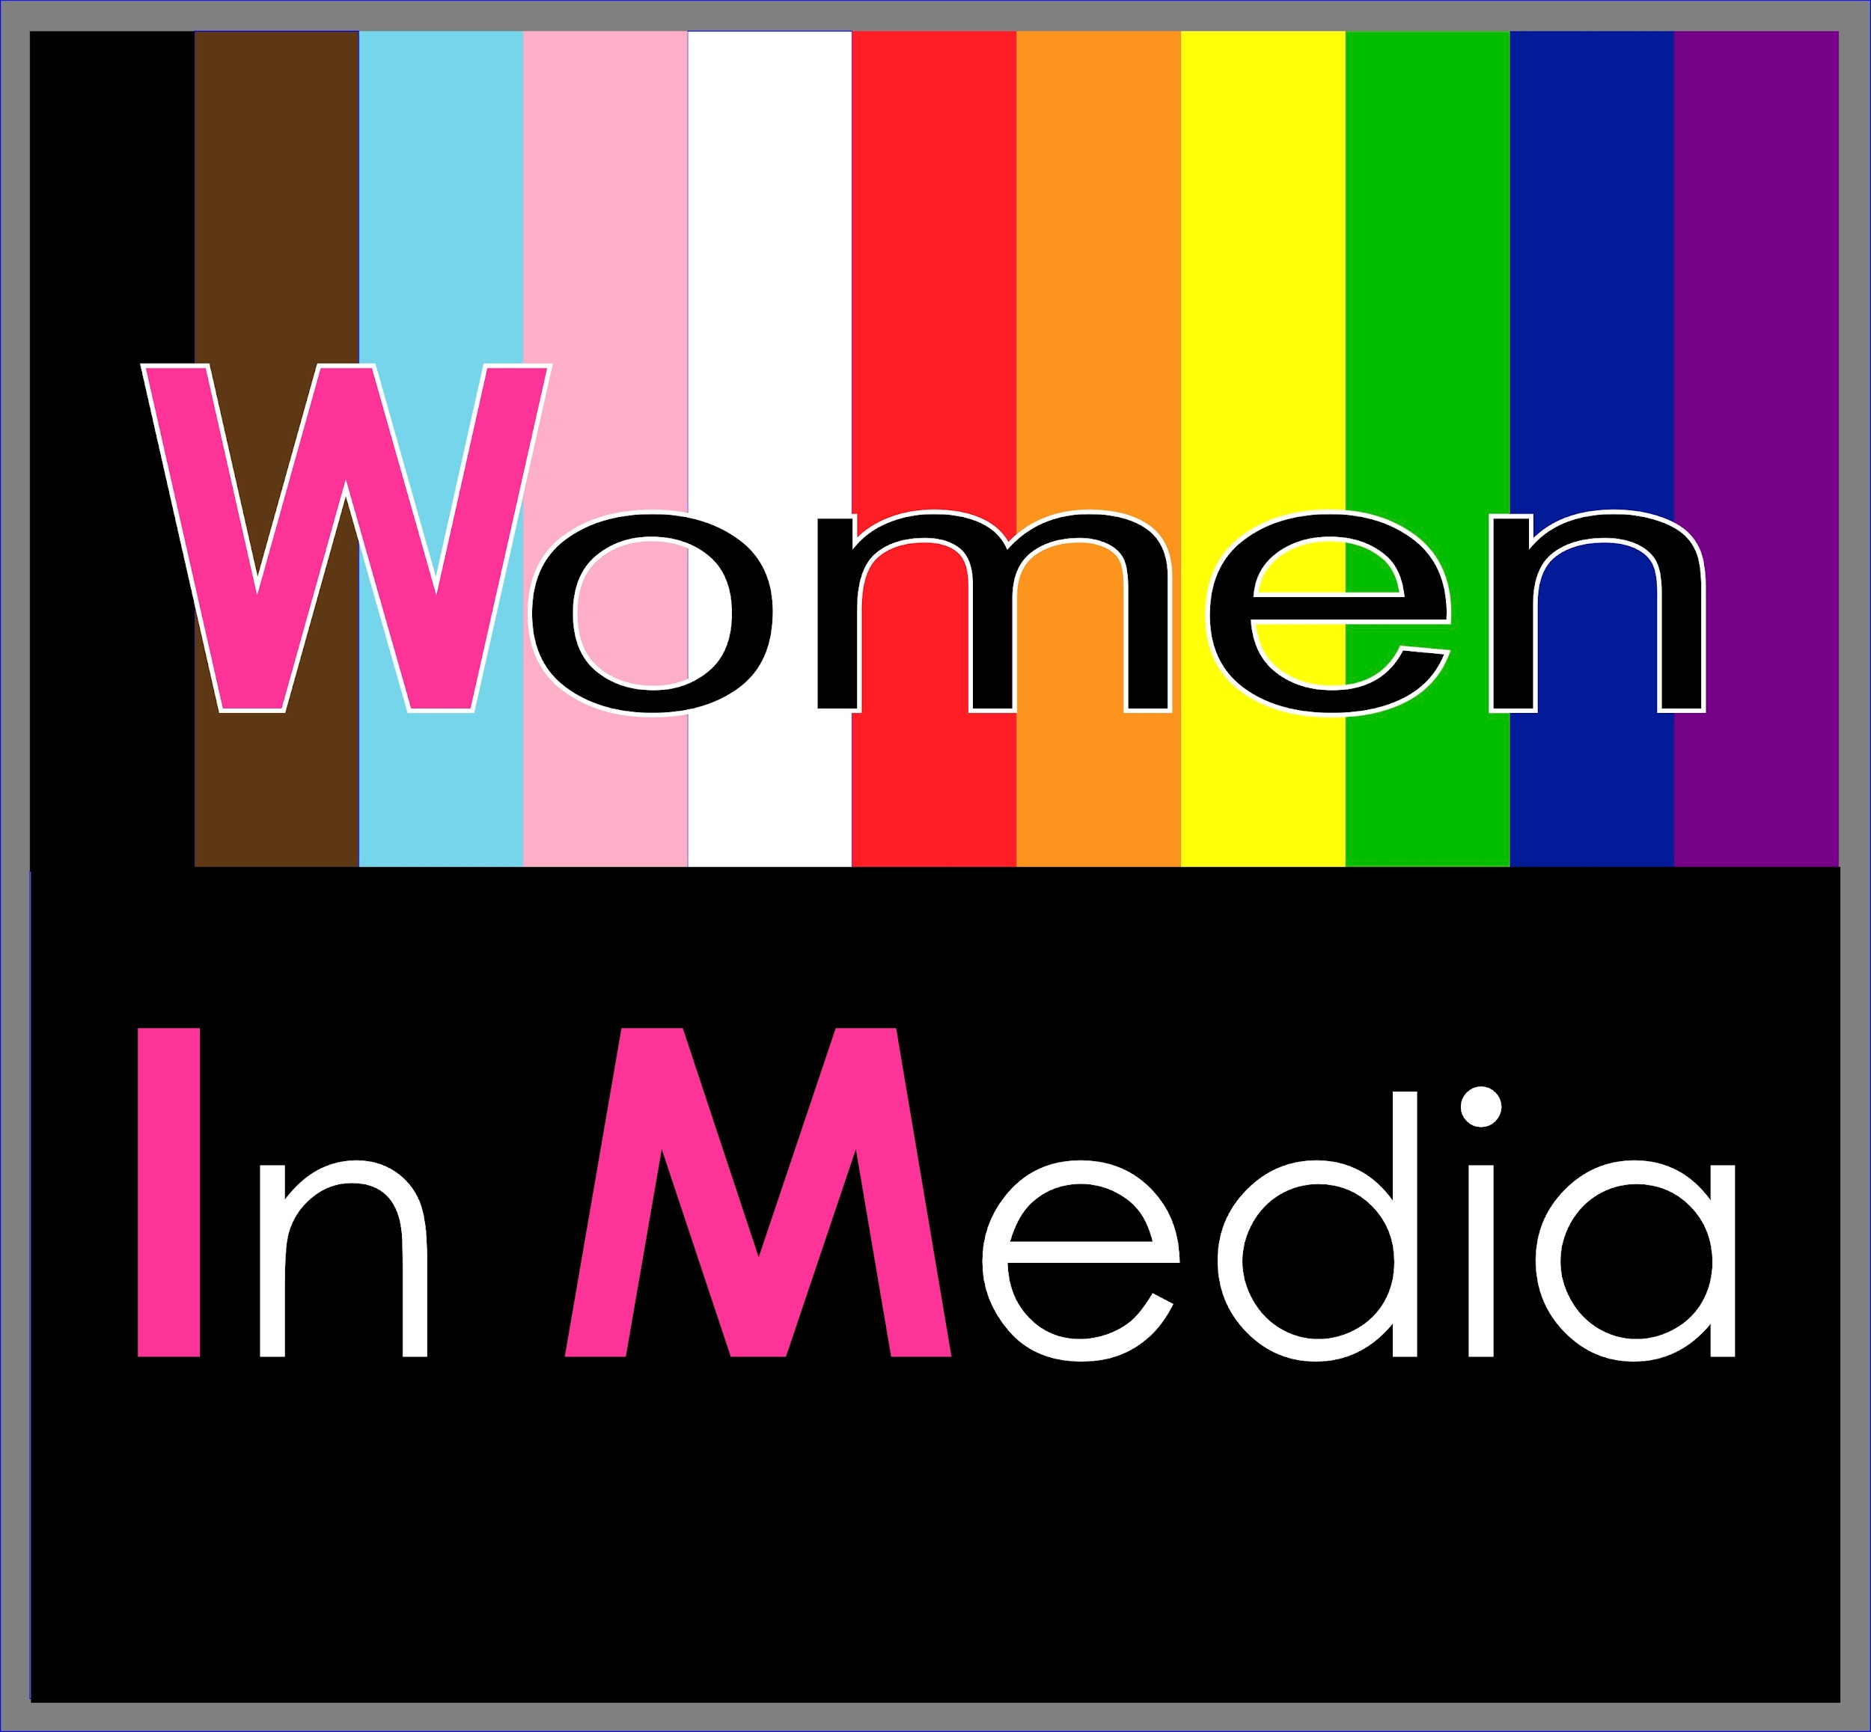

News Release
FOR IMMEDIATE RELEASE
Effective December 8, 2023
www.womennmedia.com

Women in Media's Annual Holiday Toast to Legendary Women
Set to Inspire & Celebrate Diversity in the Entertainment Industry
Beverly Hills, CA — Women In Media, a leading organization dedicated to promoting diversity and inclusion within the entertainment industry, announces that its Annual Holiday Toast to Legendary Women in the Industry is being held on December 16, 2023 at the renowned Hotel Sofitel in Beverly Hills.
Each year, Women In Media recognizes and celebrates truly legendary women who have made an indelible mark in the entertainment field. These distinguished filmmakers have not only paved the way for greater female participation behind the scenes but have also become trailblazers and inspirational figures for professionals working in the industry.
This toast will welcome friends, industry luminaries, and Women In Media members to join in honoring these exemplary women. Attendees will witness colleagues sharing stories of the honorees' professionalism, artistry, and craft, creating an atmosphere of appreciation, inspiration, and empowerment.
The highlight of the day will be a special panel featuring honorees Natasha Foster-Owens, Senior Vice President, Production at HBO (Insecure, Divorce, A Black Lady Sketch Show, Staircase, Wizard of Lies) Jen Underdahl, Vice President: VFX at Marvel Studios (Loki, WandaVision, The Avengers), Stephanie Filo, Editor who is a 2023 three-time Emmy Nominee for Monster: The Jeffrey Dahmer Story, A Black Lady Sketch Show, History of the World: Part II), and Dianne Farrington, Camera Operator on Moesha, Mad About You, The Nutty Professor, and Cinematographer on Making the Five Heartbeats.
The festivities kick off with Premiere VIP Entry at 10:30am and General Admission at 11:30am. After arriving on the red carpet, guests may enjoy a sumptuous brunch, liquid libation, and inspiring stories from esteemed industry leaders. The audience is invited to raise their glasses and join in the champagne toast to legendary women, paving the way for a more inclusive industry.
Interested parties can get tickets while they last at: https://womennmedia.com/event/holiday-toast-2023/

###

About Women In Media
In 2010, Women In Media started as an informal group of like minded folks who wanted to network and hire more women. In 2017, WiM became a 501(c)(3) Charity ~ EIN# 82-1807178, and expanded services to include education and initiatives. The cornerstone program is the CAMERAderie Initiative, which has boosted the careers of women and gender non-conforming folks from every department in the crew with development, production, and post production of high production short films. Through mentorship, education, and long term support, with an eye towards sustainable jobs, WiM has helped propel the industry closer to the goal of equality for women and gender non-conforming folks working in every crew, every department, on every show. For more information on Women In Media, visit www.womennmedia.com.

###

